**Project 6 Coin Detection – Part 1 – voting for centers**

Name: Arnav Jain Period: 3 Date: 02/13/2022

Did you name your file l061.cpp (Lower case L, then 061)? yes

Did you create the edge matrix? yes

Did you create the gradient direction matrix? yes

Did you create the imagev.ppm (visual of votes)? yes

Did you use Bresenham's line algorithm for voting? yes

Did you test on the terminal/jupyterhub? yes

Below for the easy image provided paste the imagev.ppm, imageCC.ppm you obtained running your code:

What are the 3 values you sed for lower/upper thresholds and also for the threshold for votes:

Lower = 100, Upper = 200, threshold = 130

imagev.ppm:

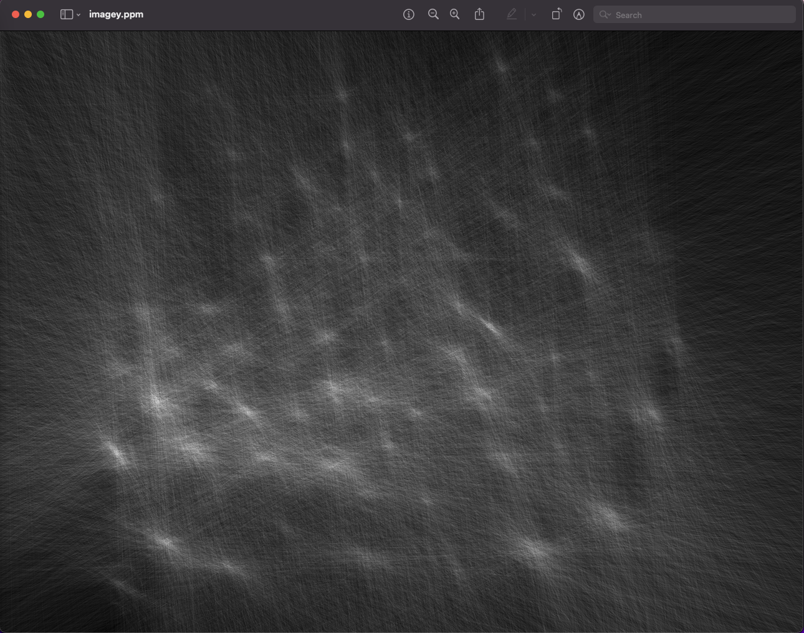

imageCC.ppm:

